**Green Society Public School**

**D-04**

**Ratnanagar-7, Sauraha, Chitwan**

**Second Terminal Examination-2082**

**Class: Nursery Time: - 2 hrs. F.M.: 50**

**Sub: Maths (W)**

|  |
| --- |
| **Name: Roll No.: Sec.:** |
| **­­­­­­­­­­­­ ________________ ______________ OBT.MARKS:**  **INVIGILATOR EXAMINER** |

**1. Match the same numbers. [5]**

3 7

7 3

10 13

13 10

19 19

**2) Circle the same Devanagari Numbers. [5]**

! M ! # %

@ M $ @ #

# M # ^ (

$ M @ $ &

% M ! ( %

**4. What comes after? [6]**

1 = _______ 5 = _______

7 = _______ 9 = _______

13= _______ 16= _______

**4) Count the pictures and colour the correct numbers. [5]**

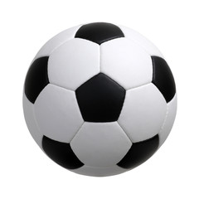

:

1

4

D:\nursery image - all\leaf.jpgD:\nursery image - all\leaf.jpgD:\nursery image - all\leaf.jpgD:\nursery image - all\leaf.jpgD:\nursery image - all\leaf.jpgD:\nursery image - all\leaf.jpg :

6

2

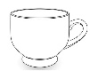 :

3

7

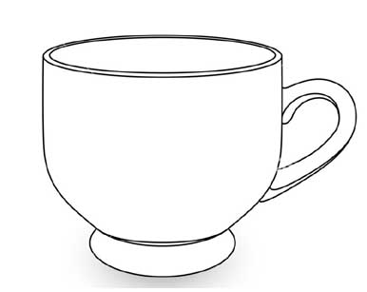

8

9

:

:

5

4

**2. Match the number with pictures. [5]**

5

6 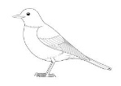

**6. Write the numbers 10 to 15. [12]**

______ ______ ______ ______

______ ______

**5. Circle the number ‘10’. [7]**

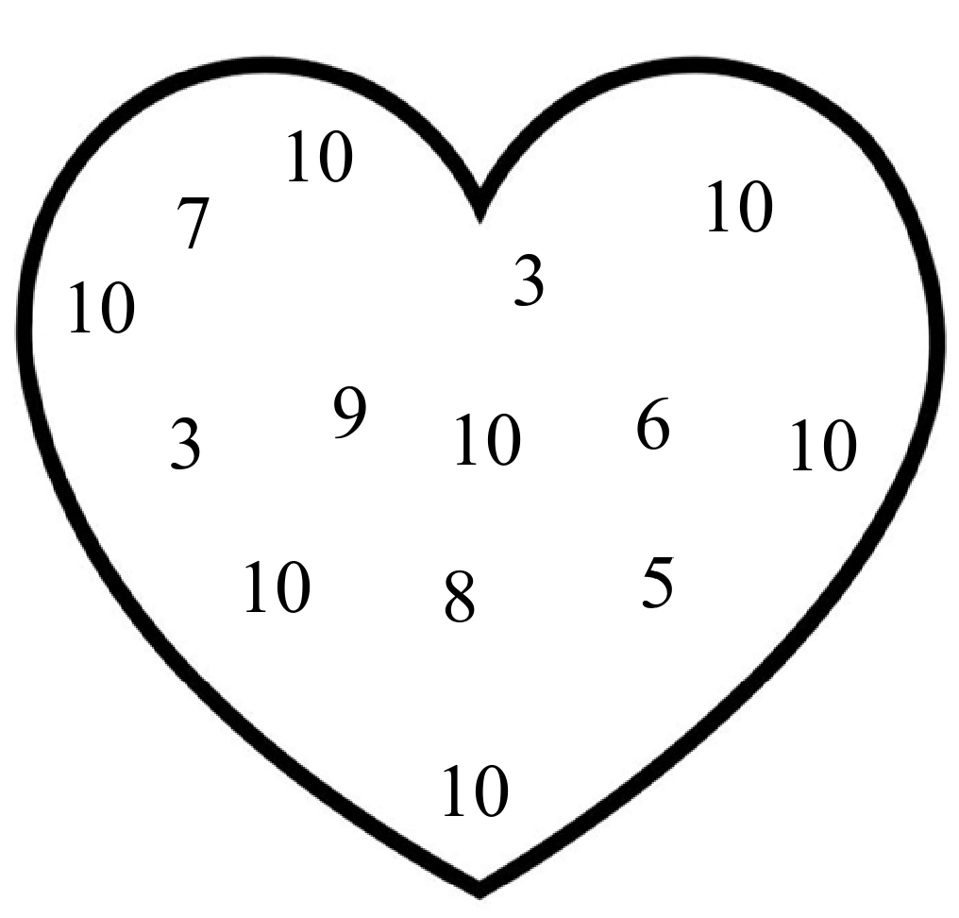

**8. Color the shapes. [5]**

**The End**